TIPS ON FLOWCHARTS AND DRAW.IO

CONTENTS
________________________________________________________________________________

FLOWCHARTS
- Introduction
- Basic Notations And Simple Flowcharts
- Modulus and more
- Variables and Decision Boxes
- Largest of 3 Numbers
- Introduction to Loops
- More on Loops
- Fibonacci Series
- Sum of Digits of a Number
- Connectors
________________________________________________________________________________

INTRODUCTION
- A flowchart is a drawn or graphical representation of any algorithm
- An algorithm is a sequence to solving a problem
- A flowchart is so called because of the flow of the chart in order of the sequence of the algorithm
- flowcharts has it’s own rules and notations

BASIC NOTATIONS AND SIMPLE FLOWCHARTS

START / STOP BOX
  - It denotes the start and end of the flowchart
INPUT / OUTPUT BOX
  - it’s used when an input is needed from the user and also to display an output to the user
PROCESS BOX
  - this is for any mathematical calcualtions in your flowchart

CONDITION
BOX
  - this is needed for checking conditions

ARROW
  - this is used for connecting all the shapes in the flowchart to show the flow of logic

CONNECTOR
  - this is used for connecting one point of the flowchart to another

example 1:
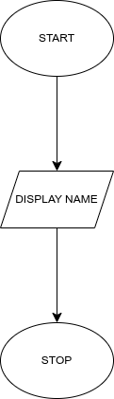example 1: displays a name

example 2:
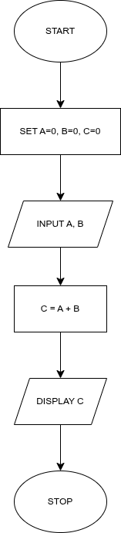Display The Sum Of Two Numbers

MODULUS AND MORE
- When working on other mathematical operations, all you need to change is the process box
- modulus is denoted as MOD
- modulus gives you the remainder after division in integerss

example 3:

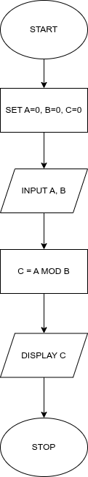

VARIABLES AND DECISION BOX

- A variable is a placeholder for data

example 4:
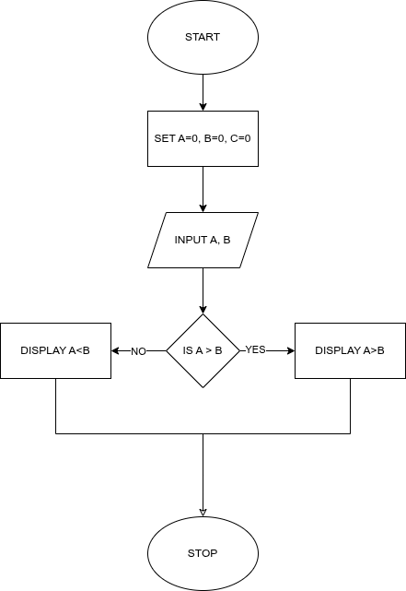

LARGEST OF 3 NUMBERS

Example 5:
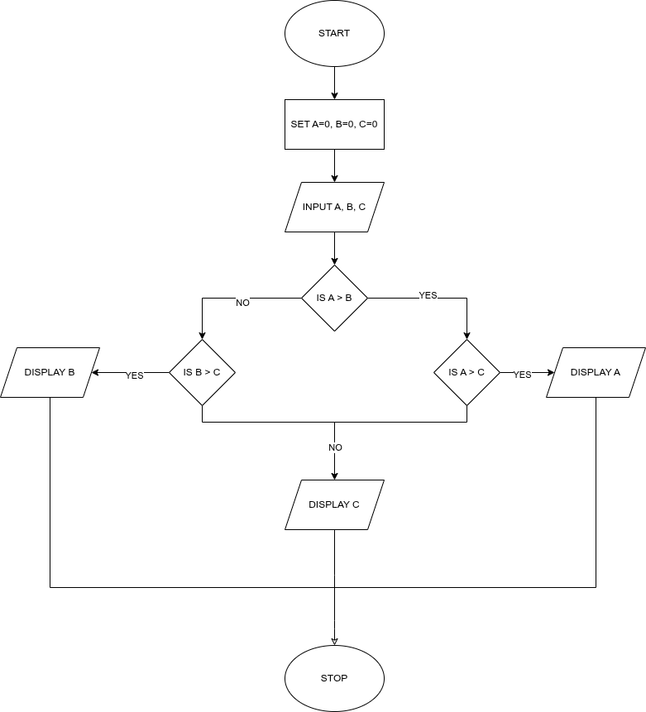

INTRODUCTION TO LOOPS

Example 6:
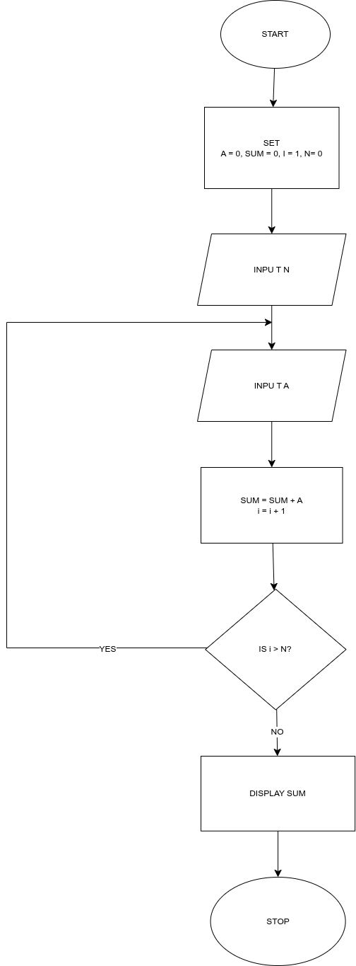

MORE ON LOOPS

Example 7:
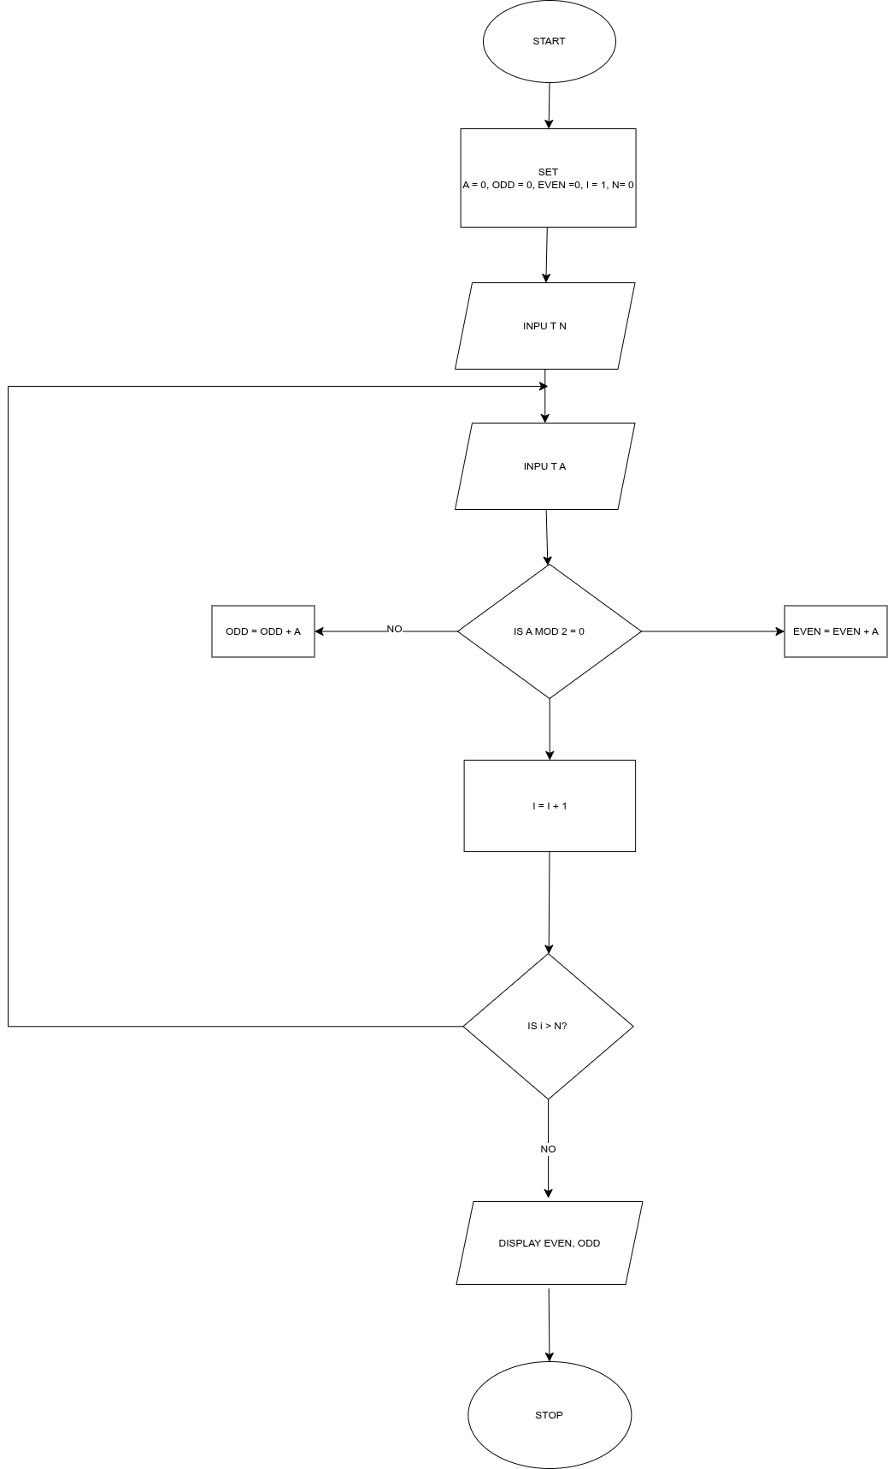

FIBONACCI SERIES
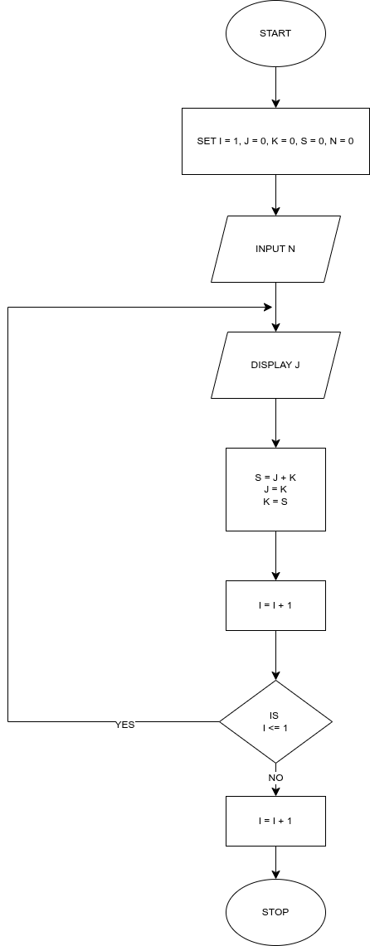

SUM OF DIGITS OF A NUMBER
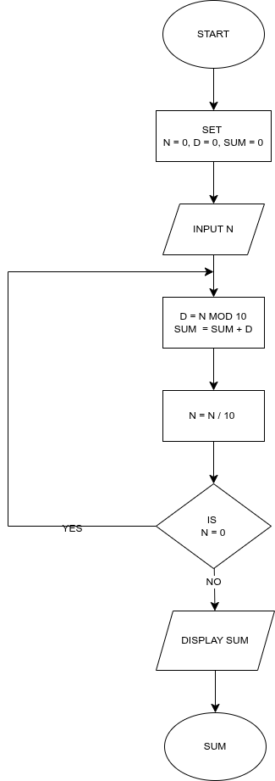

CONNECTORS
